# Assignment -1

Python Programming

|  |  |
| --- | --- |
| Assignment Date | 4th November 2022 |
| Student Name | Bagavath.P |
| Student Roll Number | 411519106002 |
| Maximum Marks | 2 Marks |

# Question-1:

1. Create registration page in html with username, email and phone number and by using POST method display it in next html page.

# Question-2:

1. Develop a flask program which should contain at least 5 packages used from pypi.org

**Note:-** Following application contains (Flask , render_template ,url_for, redirect, request) So both Questions have same Answers

# Source Code: App.py

*from* tkinter.tix *import* Form

*from* flask *import* Flask ,render_template,url_for,redirect,request app = Flask( name )

@*app*.*route*('/') def *index*():

*return* render_template("index.html") @*app*.*route*('/success/<name>/<phone>/<email>') def *success*(name=None,phone=None,email=None):

*return* " <h1>Registered Successfully</h1><h2>Your Details Are:-</h2> {}

<br>{} <br> {} ".format(name , phone ,email)

# *'{} {} {}'.format(firstname, lastname, cellphone)*

@*app*.*route*("/login",methods =['POST','GET']) def *login*():

*if* request.method == 'POST':

user = request.form['name'] email = request.form['email'] phone = request.form['phone']

*return* redirect(url_for("success", name = user ,phone = phone ,email =

email ))

*else*:

user = request.args.get("input_name")

*return* redirect(url_for("success",name=user))

*if* name == ' main ': app.run(debug=True)

**index.html**

<!DOCTYPE *html*>

<html *lang*="en">

<head>

<meta *charset*="UTF-8">

<meta *http-equiv*="X-UA-Compatible" *content*="IE=edge">

<meta *name*="viewport" *content*="width=device-width, initial-scale=1.0">

<link *rel*="stylesheet" *href*="/static/style.css">

<link *rel*="stylesheet" *href*="[https://cdn.jsdelivr.net/npm/bootstrap@5.2.0/dist/css/bootstrap.min.css](https://cdn.jsdelivr.net/npm/bootstrap%405.2.0/dist/css/bootstrap.min.css)"

*integrity*="sha384- gH2yIJqKdNHPEq0n4Mqa/HGKIhSkIHeL5AyhkYV8i59U5AR6csBvApHHNl/vI1Bx" *crossorigin*="anonymous">

<title>Registration page </title>

</head>

<body>

<form *method*="post" *action*="login">

<h1>REGISTRATION PAGE</h1>

<div *class*="mb-3">

<label *for*="name" *class*="form-label">Enter the name</label>

<input *type*="text" *class*="form-control" *id*="name " *name*="name" *placeholder*="NAME">

</div>

<div *class*="mb-3">

<label *for*="exampleInputEmail1" *class*="form-label">Email address</label>

<input *type*="email" *class*="form-control" *name*="email" *id*="exampleInputEmail1" *placeholder*="EMAIL">

</div>

<div *class*="mb-3">

<label *for*="phone" *class*="form-label">Enter the phone number</label>

<input *type*="text" *class*="form-control" *name*="phone" *id*="phone" *placeholder*="PHONE NUMEBER">

</div>

<button *type*="submit" *class*="btn btn-primary">Submit</button>

</form>

</body>

</html>

# Style.css

body{

background-color: aqua !important; display: flex;

flex-direction: column; align-items: center; justify-content: center;

}

form{

display: flex;

flex-direction: column; align-items: center; justify-content: center; background-color:#fff; width: 40%;

height: 400px; border-radius: 50px; margin: 100px;

}

h2{

font-size: large; font-weight:bolder;

}

input{

width: 80% !important;

}

div{

display: flex; align-items: center;

justify-content: center; flex-direction: column; width: 90%;

}

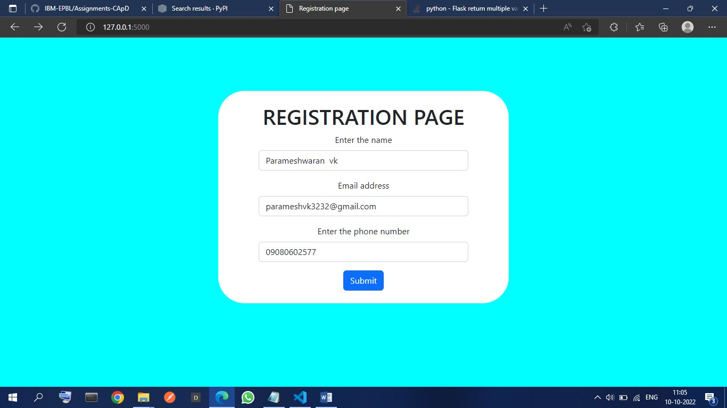**Output:- Index Page:-**

# Login successful page

